Press release

SLOTLIGHT infinity opens up new dimensions of flexibility
With the SLOTLIGHT II product range, Zumtobel combines pure feel-good light with excellent lighting effects in one LED light line. Light is not only directed along homogeneously lit lines, but also skilfully guided around corners. The successful solution is now being extended by intelligent innovations which considerably facilitate handling and lighting design: with SLOTLIGHT infinity, Zumtobel presents this spring the world’s first consistent LED light line – opening up a new dimension in design.
Dornbirn, May 2015 – Zumtobel's SLOTLIGHT II LED light line cannot fail to impress on account of its perfectly homogeneous illumination from end to end. The light line helps to enhance structurally relevant room axes, which makes the luminaires popular among designers – thanks to luminous L connectors, room geometries, too, can be emphasised particularly well. Here, the connectors arranged in 90° angles are part of the luminaire, so that no annoying shadows are visible, neither on the butt joints nor in the corners. Thus, their consistent, virtually end-to-end illumination is just as perfect as that of the dead straight light lines, and corner situations can be better focussed using light as a tool.
The extended version of SLOTLIGHT infinity is provided with an opal optic supplied with a continuous diffuser that can be up to 20 metres long. Thus, SLOTLIGHT infinity makes it possible to create a consistent continuous-row system without any shadows or overlapping, providing architects and lighting designers with virtually unlimited flexibility. Smaller lighting modules with LED lighting points that can have any spacing pitch and luminaire lengths in multiples of 250 mm increase the scope for high-precision design and allow custom-fit configuration of the light line. Zumtobel has also simplified installation of the new generation's recessed version. A uniform appearance is ensured by prefabricated frames and spacers. The separation of luminaire body and frame allows the installers or drywall builders to perfectly integrate the continuous-row system in suspended ceilings. Thus, SLOTLIGHT infinity is an element of structural design that presents itself to the beholder as a consistent light line.
Analogous to its predecessor, SLOTLIGHT infinity is also available as surface-mounted, recessed and pendant luminaire and is supplied in the colour temperatures 3000 K and 4000 K. With an efficiency of 92 lm/W and 1200 lm per running meter, the light line is a role model in terms of economic efficiency as well.

SLOTLIGHT facts & figures
- Slim LED light line
- Consistent continuous-row system with diffusers ranging from 1 m to 20 m
- Homogeneous emission of light, even in corner situations
- Silver housing, opal PC diffuser
- Frames and spacers available for facilitated installation and uniform appearance
- Installation: pendant, surface-mounted and recessed
- Optionally available with presence detection
- Lighting efficiency of up to 92 lm/W
- Colour temperatures of 3000 K or 4000 K
- Excellent colour rendering of Ra > 80
- LED and optics in IP 54
- Service life: 50000 hours

Captions:
(Photo credits: Zumtobel)
Fig. 1: SLOTLIGHT infinity opens up a new dimension in design.
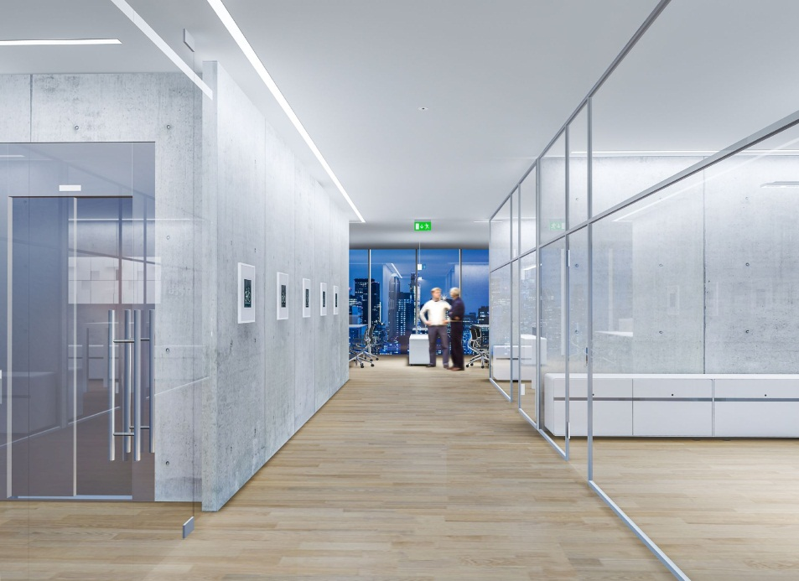
Fig. 2: The extended version of SLOTLIGHT infinity is provided with an opal optic supplied with a continuous diffuser that can be up to 20 metres long.

Press contact:
Zumtobel Lighting GmbH
Sophie Moser
PR Manager
Schweizer Strasse 30
A-6850 Dornbirn

Tel +43-5572-390-26527
Mobil +43-664-80892-3074
E-Mail press@zumtobel.com
www.zumtobel.com

Sales contact:
Zumtobel Lighting Ltd.  Chiltern Park  Chiltern Hill, Chalfont St Peter  Buckinghamshire SL9 9FG  United Kingdom  Tel: +44 1753 482 650  Fax: +44 1753 480 350  uksales@zumtobel.com  www.zumtobel.co.uk | Zumtobel Lighting Inc.  3300 Route 9  Highland , NY 12528  United States  Tel: +1 845 691-6262  Fax: +1 845 691-6289  zli.us@zumtobelgroup.com  www.zumtobel.us

For further contact details in further sales regions please visit: http://www.zumtobel.com/com-en/contact.html

About Zumtobel
Zumtobel, a leading international supplier of integral lighting solutions, enables people to experience the interplay of light and architecture. As a leader in innovation, Zumtobel provides a comprehensive range of high-quality luminaires and lighting management systems for professional interior lighting in the areas of offices, education, presentation & retail, hotel & wellness, health, art & culture as well as industry. Zumtobel is a brand of Zumtobel AG with its head office in Dornbirn, Vorarlberg (Austria).
Zumtobel. The Light.

