Press information

Stop the clock!
REFA time study: LITECOM wins by a clear margin
An independent study from REFA Consulting has proved that the commissioning of a lighting management system with LITECOM is significantly faster than with a comparable KNX system. The research showed potential time savings of up to 74 percent.
Dornbirn, July 2015 – Intelligent lighting management and control systems are essential for a high quality, user-centred and energy efficient lighting solution. DALI-based solutions such as LITECOM are often compared with KNX systems, based on building services technology. These two systems are fundamentally different in terms of functionality, components, installation, commissioning, configuration and, crucially, operation.
Which system offers the best possible support for the operator, the installer and the end-user?
REFA Consulting GmbH, part of the REFA Association for work research, business organisation and corporate development, set about answering this question by comparing a KNX system with the LITECOM lighting management system. The analysis of individual steps and the time required for these revealed valuable information about the extent to which these systems deliver on their promises of simplicity and security.
The research focused on a simulated office space with two continuous light bands made up of three DALI luminaires. One light band was situated near the window and the other was mounted further back in the room, with a blind to help create various different lighting scenarios. The results of this research were unequivocal:
- The installer required 13 minutes for the configuration and addressing of the lighting system with LITECOM, based on an average time from three installations. In comparison, it took the same installer 49 minutes to put the same solution into operation using a KNX system.
- A clear advantage of LITECOM is reflected in the ease of use. Even without expert knowledge, optimum installation and configuration can be achieved after a short briefing – even when it comes to elaborate lighting installations. The addressing wizard function guides the user through each step of the commissioning process and thereby makes lighting and building control accessible to all.

About LITECOM
The LITECOM lighting management system puts the focus firmly on the user in every respect. During the extensive product development process, maximum visual comfort and the individual adaptability of the lighting solution were just as important as an intuitive user interface for installation, configuration, commissioning and operation.
The core of the LITECOM system is the compact controller, which is designed with three DALI lines that each has capacity for 64 DALI devices. The LM-Bus also offers the possibility to connect up to 250 devices and actuators. In addition to daylight, time or absence-dependent control standards, a unique LITECOM app concept gives users the chance to manage tunableWhite applications or highly innovative solutions involving luminaires such as SEQUENCE. Blinds or control points can be integrated via the LM-BUS and a TCP/IP interface is also available. This enables monitoring and operation using smartphones, tablets, laptops, PCs, traditional switches or Zumtobel control points.

Photo captions:
(Photo credits: Zumtobel)
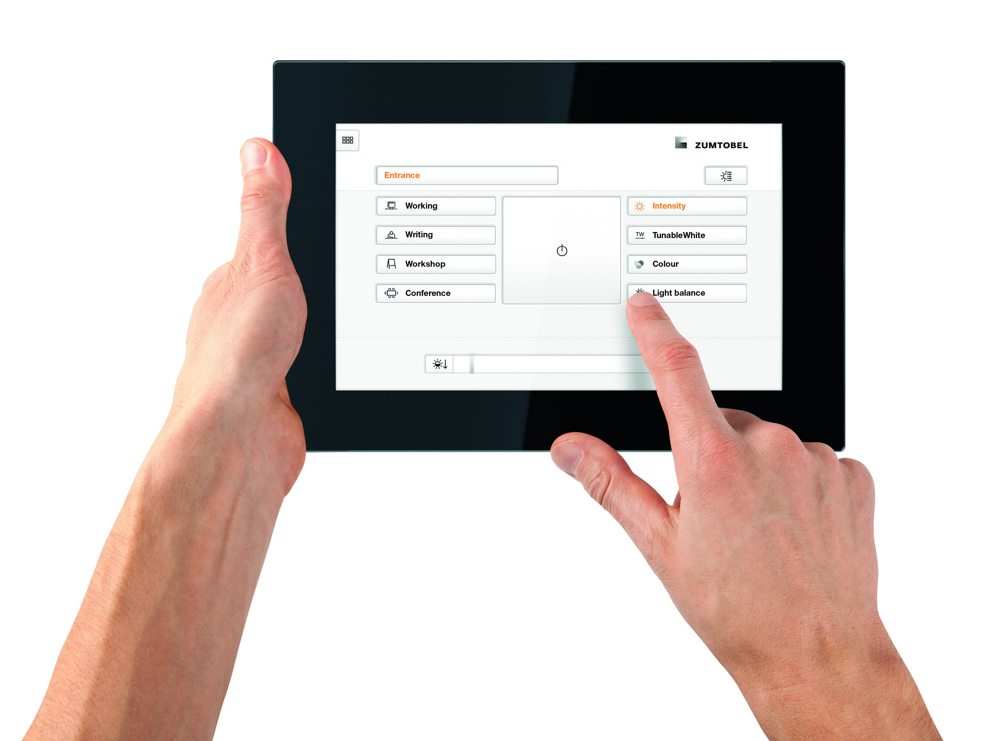
Photo 1: An independent time study from REFA Consulting has proved that the commissioning of a lighting management system with LITECOM is significantly faster than with a comparable KNX system.
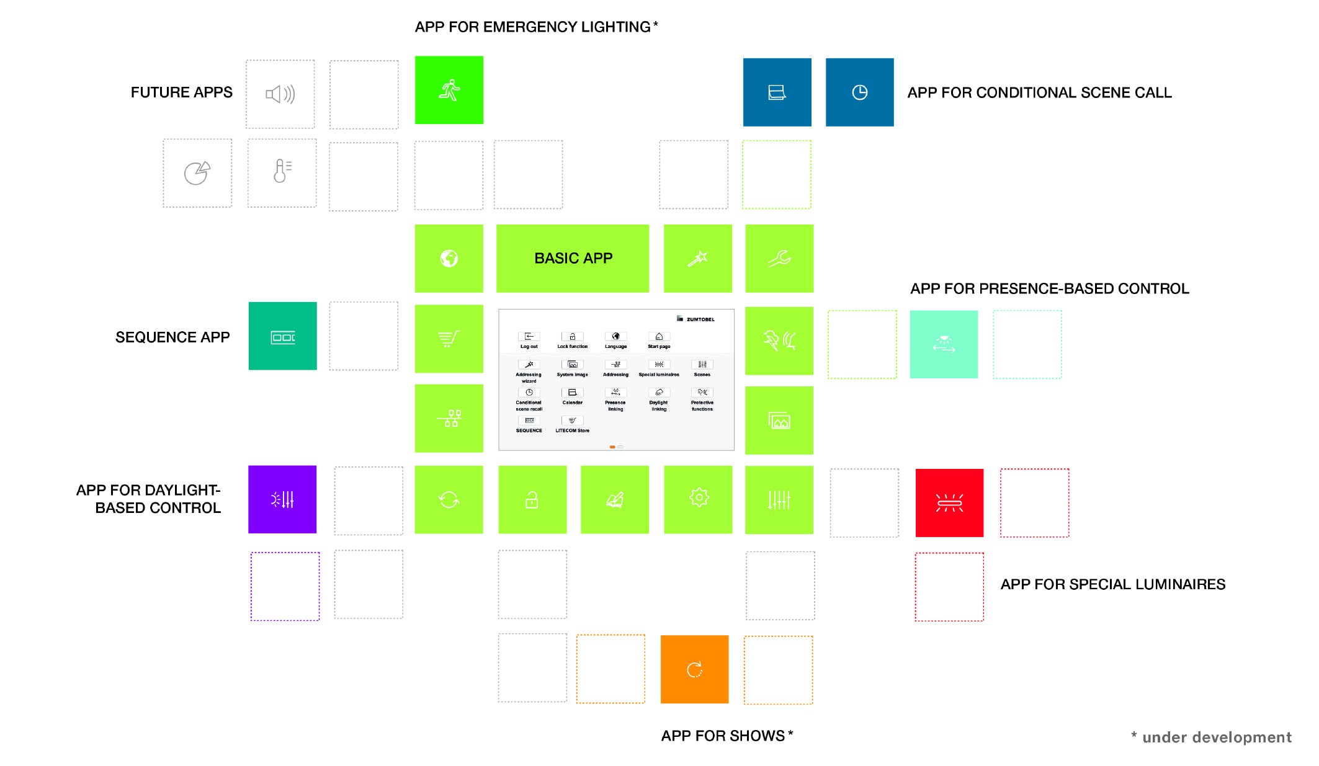
Photo 2: Thanks to the modular app concept, LITECOM can be used to control any number of different luminaires.

Press contact:
Zumtobel Lighting GmbH
Sophie Moser
Head of Brand Communications
Schweizer Strasse 30
6850 Dornbirn
Austria

Tel: +43 5572 390 26527
Mobil: +43 664 80892 3074
press@zumtobel.com

www.zumtobel.com

Sales contact:
Zumtobel Lighting Ltd.  Chiltern Park  Chiltern Hill, Chalfont St Peter  Buckinghamshire SL9 9FG  United Kingdom  Tel: +44 1753 482 650  Fax: +44 1753 480 350  uksales@zumtobel.com  www.zumtobel.co.uk | Zumtobel Lighting Inc.  3300 Route 9  Highland , NY 12528  United States  Tel: +1 845 691 6262  Fax: +1 845 691 6289  zli.us@zumtobelgroup.com  www.zumtobel.us

For further contact details in further sales regions please visit: http://www.zumtobel.com/com-en/contact.html

About Zumtobel
Zumtobel, a leading international supplier of integral lighting solutions, enables people to experience the interplay of light and architecture. As a leader in innovation, Zumtobel provides a comprehensive range of high-quality luminaires and lighting management systems for professional interior lighting in the areas of offices, education, presentation & retail, hotel & wellness, health, art & culture as well as industry. Zumtobel is a brand of Zumtobel Group AG with its head office in Dornbirn, Vorarlberg (Austria).
Zumtobel. The Light.

