Press Release

Zumtobel at Light + Building 2016
“Your light for life”: light as a conductor for the circadian rhythm
Dornbirn, 2 February 2016 – At the Light + Building trade fair that will be held from 13 to 18 March 2016, Zumtobel will show the versatility of light in professional and for the first time also in residential applications. Under the motto “Zumtobel. Your light for life”, the Austrian lighting supplier will present new product highlights and trend-setting lighting concepts that provide the right lighting solution for every individual throughout the day and at night: in the morning, the right light helps you get awake and not just up, it increases your sense of well-being at the workplace, turns shopping into an event, sets artworks centre stage, provides orientation and safety when it is dark, and offers peace and rest in the evening. This flexible lighting becomes possible only thanks to the connection of lighting and intelligent control, as well as a corresponding service package. In addition to the new Living application area added to the company's portfolio, innovative Zumtobel products for architectural and urban outdoor lighting set a new milestone as well.
“Zumtobel puts the focus on people's individual requirements, 24 hours a day. We create measurable and observable added value only by consistently focusing on the user and knowing all about the effects of light on the human body. This is the only way for us to develop lighting solutions that meet the demanding requirements of our customers, both in terms of technology and aesthetics. It allows us to do justice to the importance of light for individuals, the economy and culture.” Christoph Mathis, Executive Vice President Zumtobel

At Zumtobel's trade fair stand (hall 2.0, stand B30/31), visitors can experience on some 340 square metres the entire range of intelligent lighting solutions. Following the natural course of daylight, the Living, Office, Industry, Shop & Retail, Art & Culture and Outdoor application areas are arranged clockwise.

- Living: Thanks to Zumtobel, light acts as a conductor for the circadian rhythm. Due to the addition of the Living area to the company's portfolio, people are accompanied by Zumtobel lighting solutions over the entire course of a day. Zumtobel's advanced product portfolio allows the lighting system to blend in perfectly into architectural structures and so that unique lighting scenes and scenarios can be created in residential areas, too.
- Office: In the area of office lighting, the focus is on people's individual needs while at the same time operating costs need to be reduced. Innovative sensor-controlled luminaires ensure that, depending on the daylight available, the correct amount of artificial lighting is added for specific tasks, thus enhancing the staff's sense of well-being. Thanks to tunableWhite technology, the colour temperature can be adjusted so that the light will stimulate people in the morning and calm them down in the evening. Additional efficiency is ensured by presence detectors dimming down the lighting if nobody is present.
- Industry: In industrial applications, light used in a purposeful manner can reduce operating costs and help people perform complex work tasks. Zumtopel has developed the ATIVO sensor to tackle the challenge of combining efficiency and optimum light levels. Whether storage facilities, production areas or open spaces: ATIVO is able to recognise how areas are utilised and thus provide perfect illumination levels for every area in combination with a lighting management system.
- Shop & Retail: The use of a target group-specific lighting concept is able to increase sales at the PoS by up to 10%. This was shown in a practical test in the context of the Limbic® Lighting laboratory study. The latest findings and background information will be presented by Zumtobel comprehensively.
- Art & Culture: Using daylight efficiently, creating an atmosphere or accents – light for Art & Culture illuminates artworks in a multifaceted manner and at the same time gently and efficiently. Here, the right combination of general lighting, accent lighting and additional wallwashers is decisive. Based on selected lighting tools such as SUPERSYSTEM, Zumtobel will illustrate the aspects that are important for conservational lighting and the presentation of artworks.
- Outdoor: This new segment of the Zumtobel portfolio provides new opportunities for task-specific illumination of paths, squares, roads and façades. The portfolio allows lighting designers and architects to develop a consistent lighting solution. Thus, SUPERSYSTEM outdoor allows targeted illumination and presentation of outdoor spaces. The innovative NIGHTSIGHT lighting tool also allows for the first time to implement lighting solutions in a consistent design and with sophisticated technology.
- Services: Zumtobel's portfolio also comprises corresponding services offered by the Zumtobel Group. At Light + Building, the Group will give an overview of the services offered, such as the NOW! service package which provides customers with a turnkey lighting solution including an all-round carefree package. In addition, the possibilities of connected lighting in the age of the “Internet of Things” will be displayed.

Further information on Zumtobel at Light + Building is available on the Internet: www.lightlive.com/LB16

Further information:
Light + Building is the world’s leading trade fair for lighting and building services technology. It takes place in Frankfurt, Germany, from 13 – 18 March.

For the first time, Zumtobel will be sharing a stand with sister lighting brands Tridonic, Zumtobel and acdc. All are part of the international Zumtobel Group. The stand will be located in hall 2, stand number A.30.

For more information about Thorn and Light + Building 2016 and to register for a stand tour visit http://www.zumtobel.com/lightbuilding2016

Captions:

(Photo credits: Zumtobel)
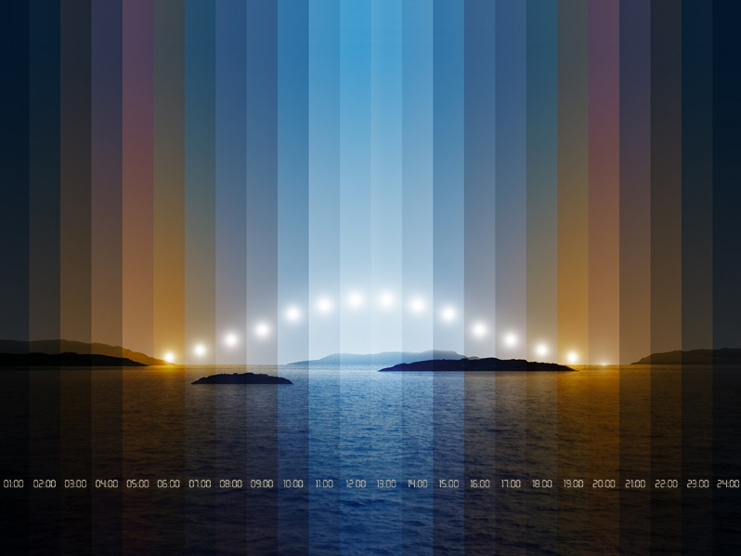
Fig. 1: Under the motto “Zumtobel. Your light for life”, Zumtobel will present new product highlights
and trend-setting lighting concepts that provide the right lighting solution for every individual throughout the day and at night.

Fig. 2: Christoph Mathis, Executive Vice President Business Division Zumtobel
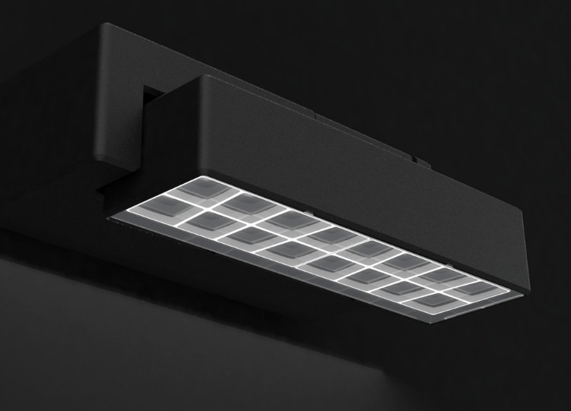
Fig. 3:
To develop the modular NIGHTSIGHT LED outdoor lighting system, Zumtobel has collaborated closely with Ben van Berkel's UNStudio experts and designers.

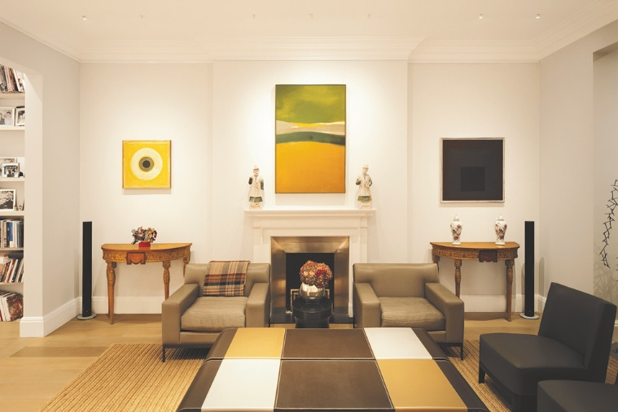
Fig. 4:
Zumtobel's advanced product portfolio allows the lighting system to blend in perfectly into architectural structures and so that unique lighting scenes and scenarios can be created in residential areas, too.

Press contact:
Zumtobel Lighting GmbH
Sophie Moser
Head of Brand Communications
Schweizer Strasse 30
6850 Dornbirn
Austria

Tel: +43 5572 390 26527
Mobil: +43 664 80892 3074
press@zumtobel.com

www.zumtobel.com

About Zumtobel
Zumtobel, a leading international supplier of integral lighting solutions, enables people to experience the interplay of light and architecture. As a leader in innovation, Zumtobel provides a comprehensive range of high-quality luminaires and lighting management systems for professional interior lighting in the areas of offices, education, presentation & retail, hotel & wellness, health, art & culture, residential and outdoor areas as well as industry. Zumtobel is a brand of the Zumtobel Group with its head office in Dornbirn, Vorarlberg (Austria).
Zumtobel. The Light.

