Press information

Zumtobel at the Lichtdesign Preis 2016

The German Lichtdesign Preis 2016 was presented in Munich on 12th May. Zumtobel featured as a partner of one of the winning projects with the Lufthansa Integrated Operation Control Center (IOCC).
Dornbirn, May 2016 – The Lichtdesign Preis was introduced to recognise the work of lighting designers who craft lighting concepts that make a significant contribution to the quality of the built environment. This year the prestigious awards were handed out on 12th May in Munich’s Löwenbräukeller. The Lufthansa Integrated Operation Control Center (IOCC) ran out a clear winner in the Office / Administration category. The illumination concept created by lighting designers Katja Winkelmann, Robert von Sichart and Juan Rivera from the Licht01 Lighting Design office from Hamburg was realised using a Zumtobel lighting solution.
The IOCC Lufthansa is located on the top floor of a Lufthansa office building at Frankfurt Airport and houses the air traffic operations for planes flying to and from Frankfurt. The control centre is manned by shift workers 24 hours a day, 365 days a year. The architectural concept was faced with the challenges of optically defining individual working areas and creating separate zones in the 2500-square-metre room with a relatively low ceiling height of around 3 metres. The lighting design plays an integral role in the fulfilment of these objectives. A customised ceiling structure developed by the architects and lighting designers works in combination with a series of illuminated ceiling panels, which are made up of backlit microprismatic panels. These also have a skylight effect, conveying an impression of daylight for workplaces that are situated well away from any windows.
Zumtobel helped implement the special lighting solution with a custom-made recessed LED luminaire. The light ceiling is controlled using the LUXMATE LITENET lighting management system, which enables the adjustment of the colour temperature between 3000 and 6000 Kelvin and the modification of the lighting intensity. The lighting solution also includes a special version of the PANOS LED downlight.
Project partners:
- Lighting designers: Licht01 Lighting Design, Hamburg (Katja Winkelmann, Juan Rivera Troncoso and Robert von Sichart)
- Client: Deutsche Lufthansa AG, Frankfurt
- Architect / Interior designer: Pielok Marquardt Architekten, Offenbach
- Electrical planner: TP-Elektroplan GmbH, Gaggenau

Photo captions:

(Photo credits: Zumtobel/Thomas Koculak)
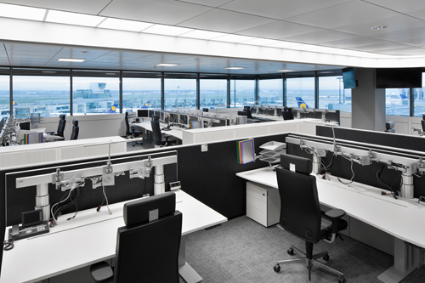
Photo 1: The illumination concept by Light 01 Lighting Design for the Lufthansa Integrated Operation Control Center (IOCC) at Frankfurt Airport wins at the German Lichtdesign-Preis in the Office/Administration category.

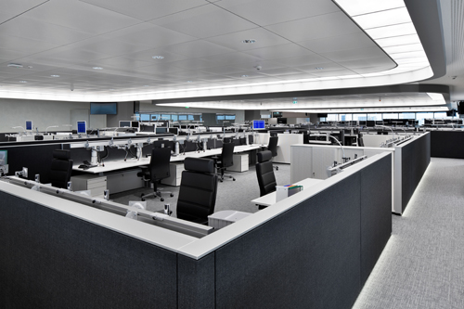
Photo 2: The customised lighting solution by Zumtobel uses illuminated ceiling panels made up of backlit micro prismatic panels to obtain a skylight effect and to convey an impression of daylight for workplaces that are situated well away from any windows.

Press contact:
Zumtobel Lighting GmbH
Andreas Reimann
Brand PR Manager
Schweizer Strasse 30
A-6850 Dornbirn

Tel: +43 5572 390 26522
Mobil: +43 664 80892 3334
press.zumtobel@zumtobelgroup.com
www.zumtobel.com

Vertrieb Deutschland, Österreich, Schweiz:
ZG Licht Süd GmbH
Beratungszentrum Frankfurt
Carl-Benz-Straße 21
60386 Frankfurt / Mannheim
Tel: +49 69 26 48 89 0
Fax: +49 69 69 26 48 89 80
info@zumtobel.de
www.zumtobel.de

ZG Lighting Austria GmbH  Beratungszentrum Wien, Niederösterreich, Burgenland  Wagramer Straße 19  A-1220 Wien  Tel: +43 1 258 2601 0  Fax: +43 1 258 2601 82845  welcome@zumtobel.at  www.zumtobel.at | Zumtobel Licht AG  Thurgauerstrasse 39  CH-8050 Zürich  Tel: +41 44 305 35 35  Fax: +41 44 305 35 36  info@zumtobel.ch  www.zumtobel.ch

About Zumtobel
As a leader in innovation, Zumtobel develops sustainable lighting solutions tailored to the needs of people in their respective applications. With a comprehensive portfolio of high-quality luminaires and intelligent lighting management systems, the Austrian company provides optimum indoor and exterior products for working and living spaces - the right light for every activity at any time of day. The applications office, education, presentation and retail, hotel and wellness, health, art and culture and industry are now perfectly complemented with portfolios for living and outdoor areas. Zumtobel is a brand of Zumtobel Group AG with its head office in Dornbirn, Vorarlberg (Austria).
Zumtobel. The Light.

