Press release
Dornbirn, January 2012

Using contrasts and light colours as a way of boosting sales
Latest findings on ideal lighting for stores

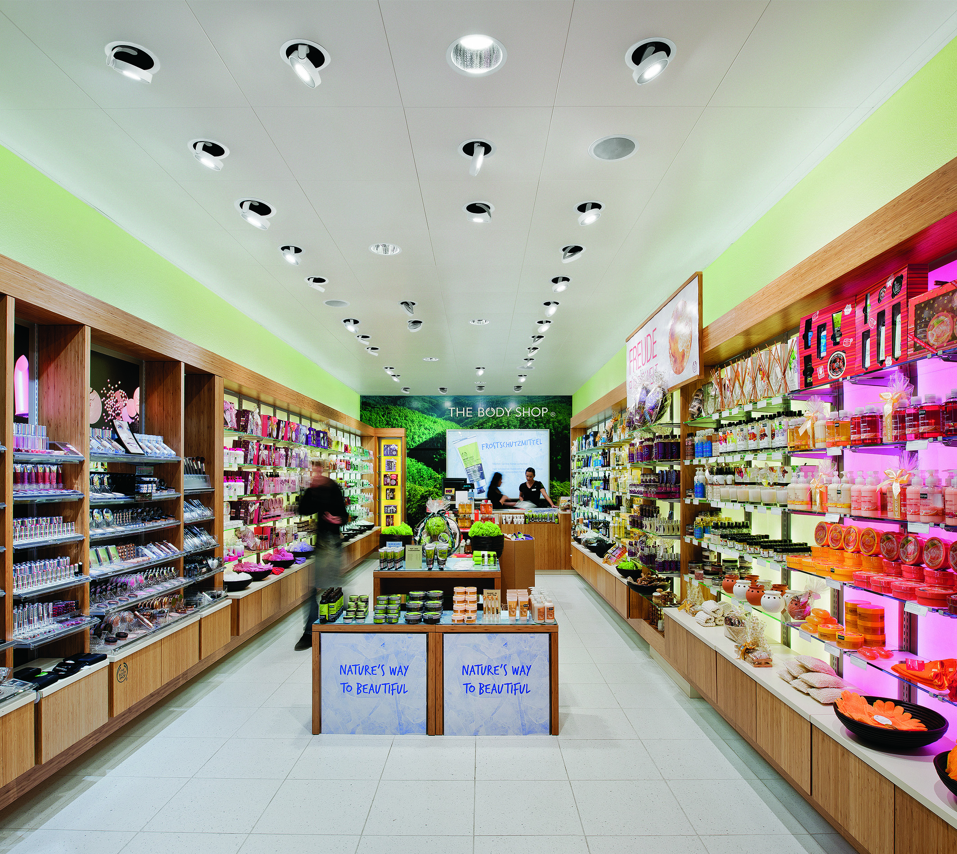
What kind of lighting do customers prefer in retail spaces? How should light be used to raise attention levels or extend the amount of time customers spend in shops? Zumtobel has got to the bottom of these and similar questions in cooperation with prestigious research institutes during the course of laboratory research and field studies. The most important findings: it is not all about brightness. Contrasts, i.e. the effect of light and dark areas, are decisive. Customer behaviour in retail areas is influenced significantly by perception and a sense of well-being. Light is an important design tool which impacts these parameters. Because light conveys emotions, lends spaces atmosphere and makes it easier for people to find their way around.

Zumtobel's latest applied research is devoted to the topic "Attention, attractiveness and perception mediated by lighting in retail spaces". Zumtobel conducted a two-part study in cooperation with Prof. Jan Ejhed, head of the lighting laboratory at the Royal Institute of Technology (KTH) in Stockholm, and Dr. Roland Greule from the Hamburg University of Applied Sciences (HAW).

The purpose of this investigation was to determine the factors that are decisive in shop lighting when it comes to selling more merchandise, increasing footfall and extending the amount of time customers spend in a shop.

Research design – Perceiving light
The first part of the study was based on the question of the extent to which lighting influences customers' subjective perceptions. In order to establish the kind of lighting situations that people prefer in shops and retail spaces, 97 subjects were asked to directly compare and assess three lighting situations in virtually displayed shopping situations.

In the second part of the study this was followed by laboratory research and a field study in cooperation with Dr. Roland Greule and Felsch Lighting Design in which the perception of the subjects in retail spaces was examined with reference to previously defined lighting parameters. The lighting factors that were to be investigated included light colour, light distribution, lighting intensity and dynamic changes in brightness or colour. Laboratory tests using test charts produced generally valid statements regarding visual effects such as contrast and colour perception. The laboratory results were then compared using real retail space situations. A Douglas perfume shop and a supermarket operated by the Austrian SPAR chain were used for the field projects. An eye-tracking camera system was used to capture subjects' eye movements using modern measuring instruments.

Results - Customers' sense of well-being must be improved
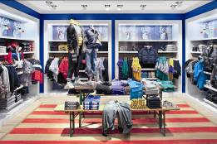
To recap the results of the investigation, it yielded technical lighting design principles that are especially insightful as far as the work of professional lighting designers is concerned. Prof. Dr. Jan Ejhed sums it up: "The study is a valuable resource and sets out key factors that should guide lighting design in shops and retail spaces. The result of this study shifts the focus of future lighting design; it shows the need to do more than simply attract the customer's attention, and identifies the need to devise a new approach that will improve customer convenience and enhance the customer's sense of well-being." Zumtobel Marketing Director Stefan Terzi goes on to say that: "This new Zumtobel study provides valuable information that can be used to develop lighting solutions and their applications in the shopping and retail sector. Thanks to our in-depth knowledge of this application area and awareness of the needs of users and the effect of light, we are in a position to develop innovative lighting systems that create measurable added value for our customers."

Summary of results - Eight design recommendations
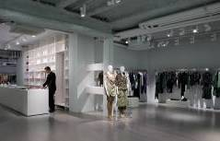
(1) Instead of increasing brightness in shops, and therefore also energy consumption, it is advisable to design lighting that is always high contrast, makes perception easier and heightens levels of attention. Pinpoint accent lighting that stands out positively from the surrounding homogeneous ambient lighting is a suitable way of creating contrasts.

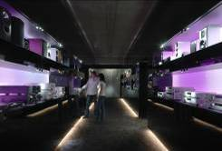
(2) Diffuse general lighting ensures a subjective sense of well-being. Vertical illuminance makes orientation easier in a room. The easier it is for customers to find their way around, the more likely they are to walk around a shop. Efforts must therefore be made to use vertical lighting to delimit the periphery of a space. At the same time, detailed accent lighting must be used to improve the perception and attractiveness of the goods displayed.

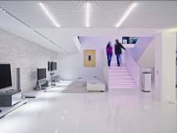
(3) Colours convey emotions and influence the acceptability of a space. The study results showed that cool colour temperatures such as cool white make areas appear more spacious whereas warm colour temperatures create an impression of smallness and familiarity. Intermediate white light extends the amount of time customers spend in a shop and improves their sense of well-being, and should therefore be used for general lighting. Anyone who prefers a shop atmosphere that makes customers feel safe and secure should opt for warm white light colours.

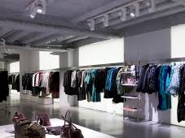
(4) There is a preference for various different light colours within a single lighting concept. Different colour temperatures should therefore be consciously deployed across general lighting and vertical lighting. The latest Tunable White LED luminaire technology makes it possible to obtain colour temperature changes using control systems, and deserves special consideration in this respect.

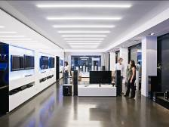
(5) There are differences in perception depending on gender, age and groups of buyers: men take in a broad overview of a retail space, for example, whereas women look at details. It is therefore important to adapt the direction of light, light colour and lighting intensity dynamically over the course of the day to make sure it is appropriate to the target group's behaviour.

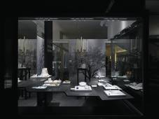
(6) Shop windows are often the customer's first point of contact with a shop: accent lighting on merchandise in addition to daylight is preferred here. This also involves using pinpoint accenting to emphasise perceived contrasts. In the evening and when there is little daylight, even low illuminance levels are sufficient to attract the curiosity of passers-by with wide-area, subtly changing ambient lighting.
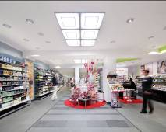
(7) Eye-tracking studies at Douglas and SPAR proved that the lower levels of shelves in particular go relatively unnoticed. Targeted accent lighting or dynamic lighting in the lower third of shelves results in customers lingering longer and may possibly boost sales. Shelf-integrated lighting is recommended in principle at all levels.

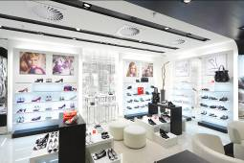
(8) The way that light is directed onto shelves is also crucial: wide-area backlighting of shelves produces a more attractive effect than accent lighting only. A combination of backlighting and accent lighting makes identification of merchandise easier and makes the presented goods look more attractive.

A planned extension of the study is set to investigate dynamic lighting control concepts for shop applications in particular.

Zumtobel. The Light.
The following were involved in the study:

Royal Institute of Technology in Sweden (KTH)
Prof. Jan Ejhed is the head of the lighting laboratory at the Royal Institute of Technology (KTH) in Sweden. He is also head of Division 3 at CIE, professor at the School of Design of the Linnaeus University and runs his own company. He brought in the student Xu Haoming to assist him in his research.

HAW Hamburg (Prof. Roland Greule)
Since 1996, Prof. Roland Greule has been professor of lighting technology at the University of Applied Sciences, as well as vice dean of the Design, Media and Information (DMI) School.

Felsch Lighting Design (Markus Felsch)
Markus Felsch studied lighting design at the HAWK Hildesheim. He has run his own company since 2004, and mainly devotes himself to perception-based lighting concepts for retail areas.

Zumtobel Lighting GmbH
Zumtobel is continually researching the effects of light in various application areas. Collaboration with prestigious research institutes provides an important network that enables the luminaire manufacturer to communicate with researchers and, together, gain new knowledge relating to the use of lighting solutions that can be harnessed for future product development work.

Brief profile
The Zumtobel brand is a leading international supplier of integral lighting solutions that enable people to experience the interplay of light and architecture. As a leader in innovation, the luminaire manufacturer provides a comprehensive range of high-quality luminaires and lighting management systems for the most varied application areas of professional interior lighting – including offices and educational facilities, retail and presentation, hotels and wellness, health and care, art and culture as well as industry and engineering. Zumtobel is a brand of the Zumtobel AG group with its head office in Dornbirn, Vorarlberg (Austria).

Captions:

Caption 1: The Bodyshop has opted for all-LED lighting supplied by Zumtobel

Caption 2: A light show involving different colour temperatures and contrasts

Caption 3: Targeted accent lighting produces high-contrast lighting

Caption 4: Diffuse ambient lighting with vertically illuminated surfaces

Caption 5: Coloured lighting designs convey emotions
Caption 6: Flexible colour temperatures (Tunable White) are an important aspect of modern retail space lighting. They accentuate materials, colours and quality in a true-to-life manner.
Caption 7: Structured retail space lighting ensures untrammelled perception
Caption 8: Shop windows entice passers-by. Shop window lighting is therefore important, grabbing attention and arousing curiosity.
Caption 9: Multifaceted retail space lighting with customised lighting at Douglas
Caption 10: Wide-area backlit shelves and subtle accent lighting make it easier for customers to find their way around and ensure that goods look attractive.

For more information, please contact:
Zumtobel Lighting GmbH
Nadja Frank
PR Manager
Schweizer Strasse 30
A-6851 Dornbirn

Tel. +43-5572-390-1303
Fax +43-5572-390-91303
nadja.frank@zumtobel.com
www.zumtobel.com
Publication of this document is free if due acknowledgement is made: Zumtobel

