Press release
Dornbirn, April 2012

Design Plus by Light+Building: three awards for Zumtobel
Microtools LED lighting system wins Best of Design Plus

Zumtobel has won the “Design Plus Award powered by Light+Building” in the Exhibitor category for even three of its products. The Microtools LED lighting system particularly impressed the jury with its minimalist design language and received a “Best of Design Plus powered by Light+Building” award. Moreover, the Iyon LED spotlight system and the Ondaria circular luminaire won awards for their outstanding product design combined with highly efficient lighting technology in each case.
Microtools – LED lighting system
The Microtools LED lighting system cannot fail to impress on account of its minimalist design language, high-quality manufacture and excellent lighting quality. Featuring high-quality design and excellent lighting quality, the Microtools LED lighting heads, the smallest currently available on the market, set new standards for shop lighting and comply with the most advanced requirements.
Iyon – LED spotlight range
The Iyon spotlight range incorporates state-of-the-art LED technology in a sophisticated design by DeluganMeissl Associated Architects. Its flowing lines give the Iyon spotlight an elegant look while ensuring perfect functionality. The unique lens-reflector system provides brilliant accent lighting with a variety of beam angles.
Ondaria – opal circular luminaire
The design (by Stefan Ambrozus) and lighting effects of the Ondaria circular luminaire speak the same language: the luminaire's slightly concave surface matches its soft design. Uniformly illuminated, Ondaria makes sure that the outlines of LED or conventional light sources are invisible, providing a harmonious ambience.

Zumtobel. The Light.
About Design Plus powered by Light+Building
As a kick-off event for Light+Building, the world's biggest trade fair for lighting and intelligent buildings, the Design Plus powered by Light+Building awards were presented in Frankfurt am Main on 15 April 2012. This award highlights the innovative power of the exhibitors present at the trade fair in the fields of lighting, electrical engineering and building automation and control. The products are evaluated by an expert jury according to key criteria such as quality of design, energy efficiency, sustainability and technical quality, among others.

Brief profile
Zumtobel is a leading international supplier of integral lighting solutions that enable people to experience the interplay of light and architecture. As a leader in innovation, the luminaire manufacturer provides a comprehensive range of high-quality luminaires and lighting management systems for the most varied application areas of professional interior lighting – including offices and educational facilities, presentation and retail, hotels and wellness, health and care, art and culture as well as industry and engineering. Zumtobel is a brand of the Zumtobel AG group with its head office in Dornbirn, Vorarlberg (Austria).

For more information, please contact:
Zumtobel Lighting GmbH  NikolausJohannson  Head of Brand Communication  Schweizer Strasse 30  A-6851 Dornbirn  Tel. +43-5572-390-26427  Fax +43-5572-390-926427  nikolaus.johannson@zumtobel.com  www.zumtobel.com | Zumtobel Lighting GmbH  Nadja Frank  PR Manager  Schweizer Strasse 30  A-6851 Dornbirn  Tel. +43-5572-390-1303  Fax +43-5572-390-91303  nadja.frank@zumtobel.com  www.zumtobel.com

Captions:
Crédits : Zumtobel, B1 Messe Frankfurt Exhibition / Pietro Sutera
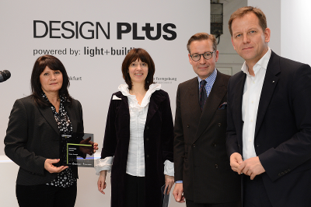

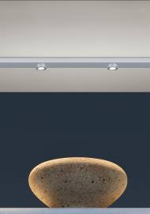
B1_ Design Plus powered by Light+Building award ceremony

B2_ The new Microtools LED system blends almost invisibly into shelves and display cabinets. The LED spotlights are currently the smallest available on the market.
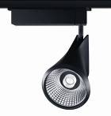

B3_ For the Iyon spotlight range, the DeluganMeissl Associated Architects studio has accommodated trend-setting LED technology in a sophisticated design.

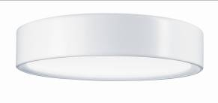

B4_ Pleasant light emitted from soft curves: the fully flexible Ondaria ceiling-mounted luminaire designed by Stefan Ambrozus blends into any interior design.

