Press release

Zumtobel illuminates Mariko Mori artwork at the Royal Academy

London / Dornbirn, December 2012 – From 13 December 2012 until 17 February 2013, the exhibition “Rebirth” by Mariko Mori will be on display at the Royal Academy in London. This is the first large-scale museum exhibition in a long time that is dedicated to the Japanese artist, who lives in New York. The subtle illumination of Birds, Drawing Room and Ring has been achieved thanks to the support of Zumtobel, a leading international supplier of integral lighting solutions.
“The creation of my work, and the way in which it is seen and engaged with, is wholly supported by Zumtobel lighting. The light touches the surface, giving it a magical effect. I am deeply honoured and grateful for Zumtobel’s commitment to my work, a relationship that has been continual since 2003. Their technology and expertise are beyond my imagination.” says the artist Mariko Mori.
Zumtobel lighting solutions are based on a profound understanding of the effects of light. Especially in museums, lighting is an important aspect. It creates worlds of experience, highlighting and enhancing the presentation of exhibits with public appeal. Last but not least, lighting experiences always represent a piece of culture, a piece of art.
Using a variety of media and forms of presentation, the exhibition “Rebirth” illustrates the various stages in a life cycle. In addition to newly created pieces, some of Mori's best known works such as the giant glass monolith Tom Na H-lu II (2006), which is illuminated by hundreds of LEDs, will also be on display.

Captions:

Tom Na H-Iu II (2005-06), one of Mori’s best known work, will also be on display at the Royal Academy in London.

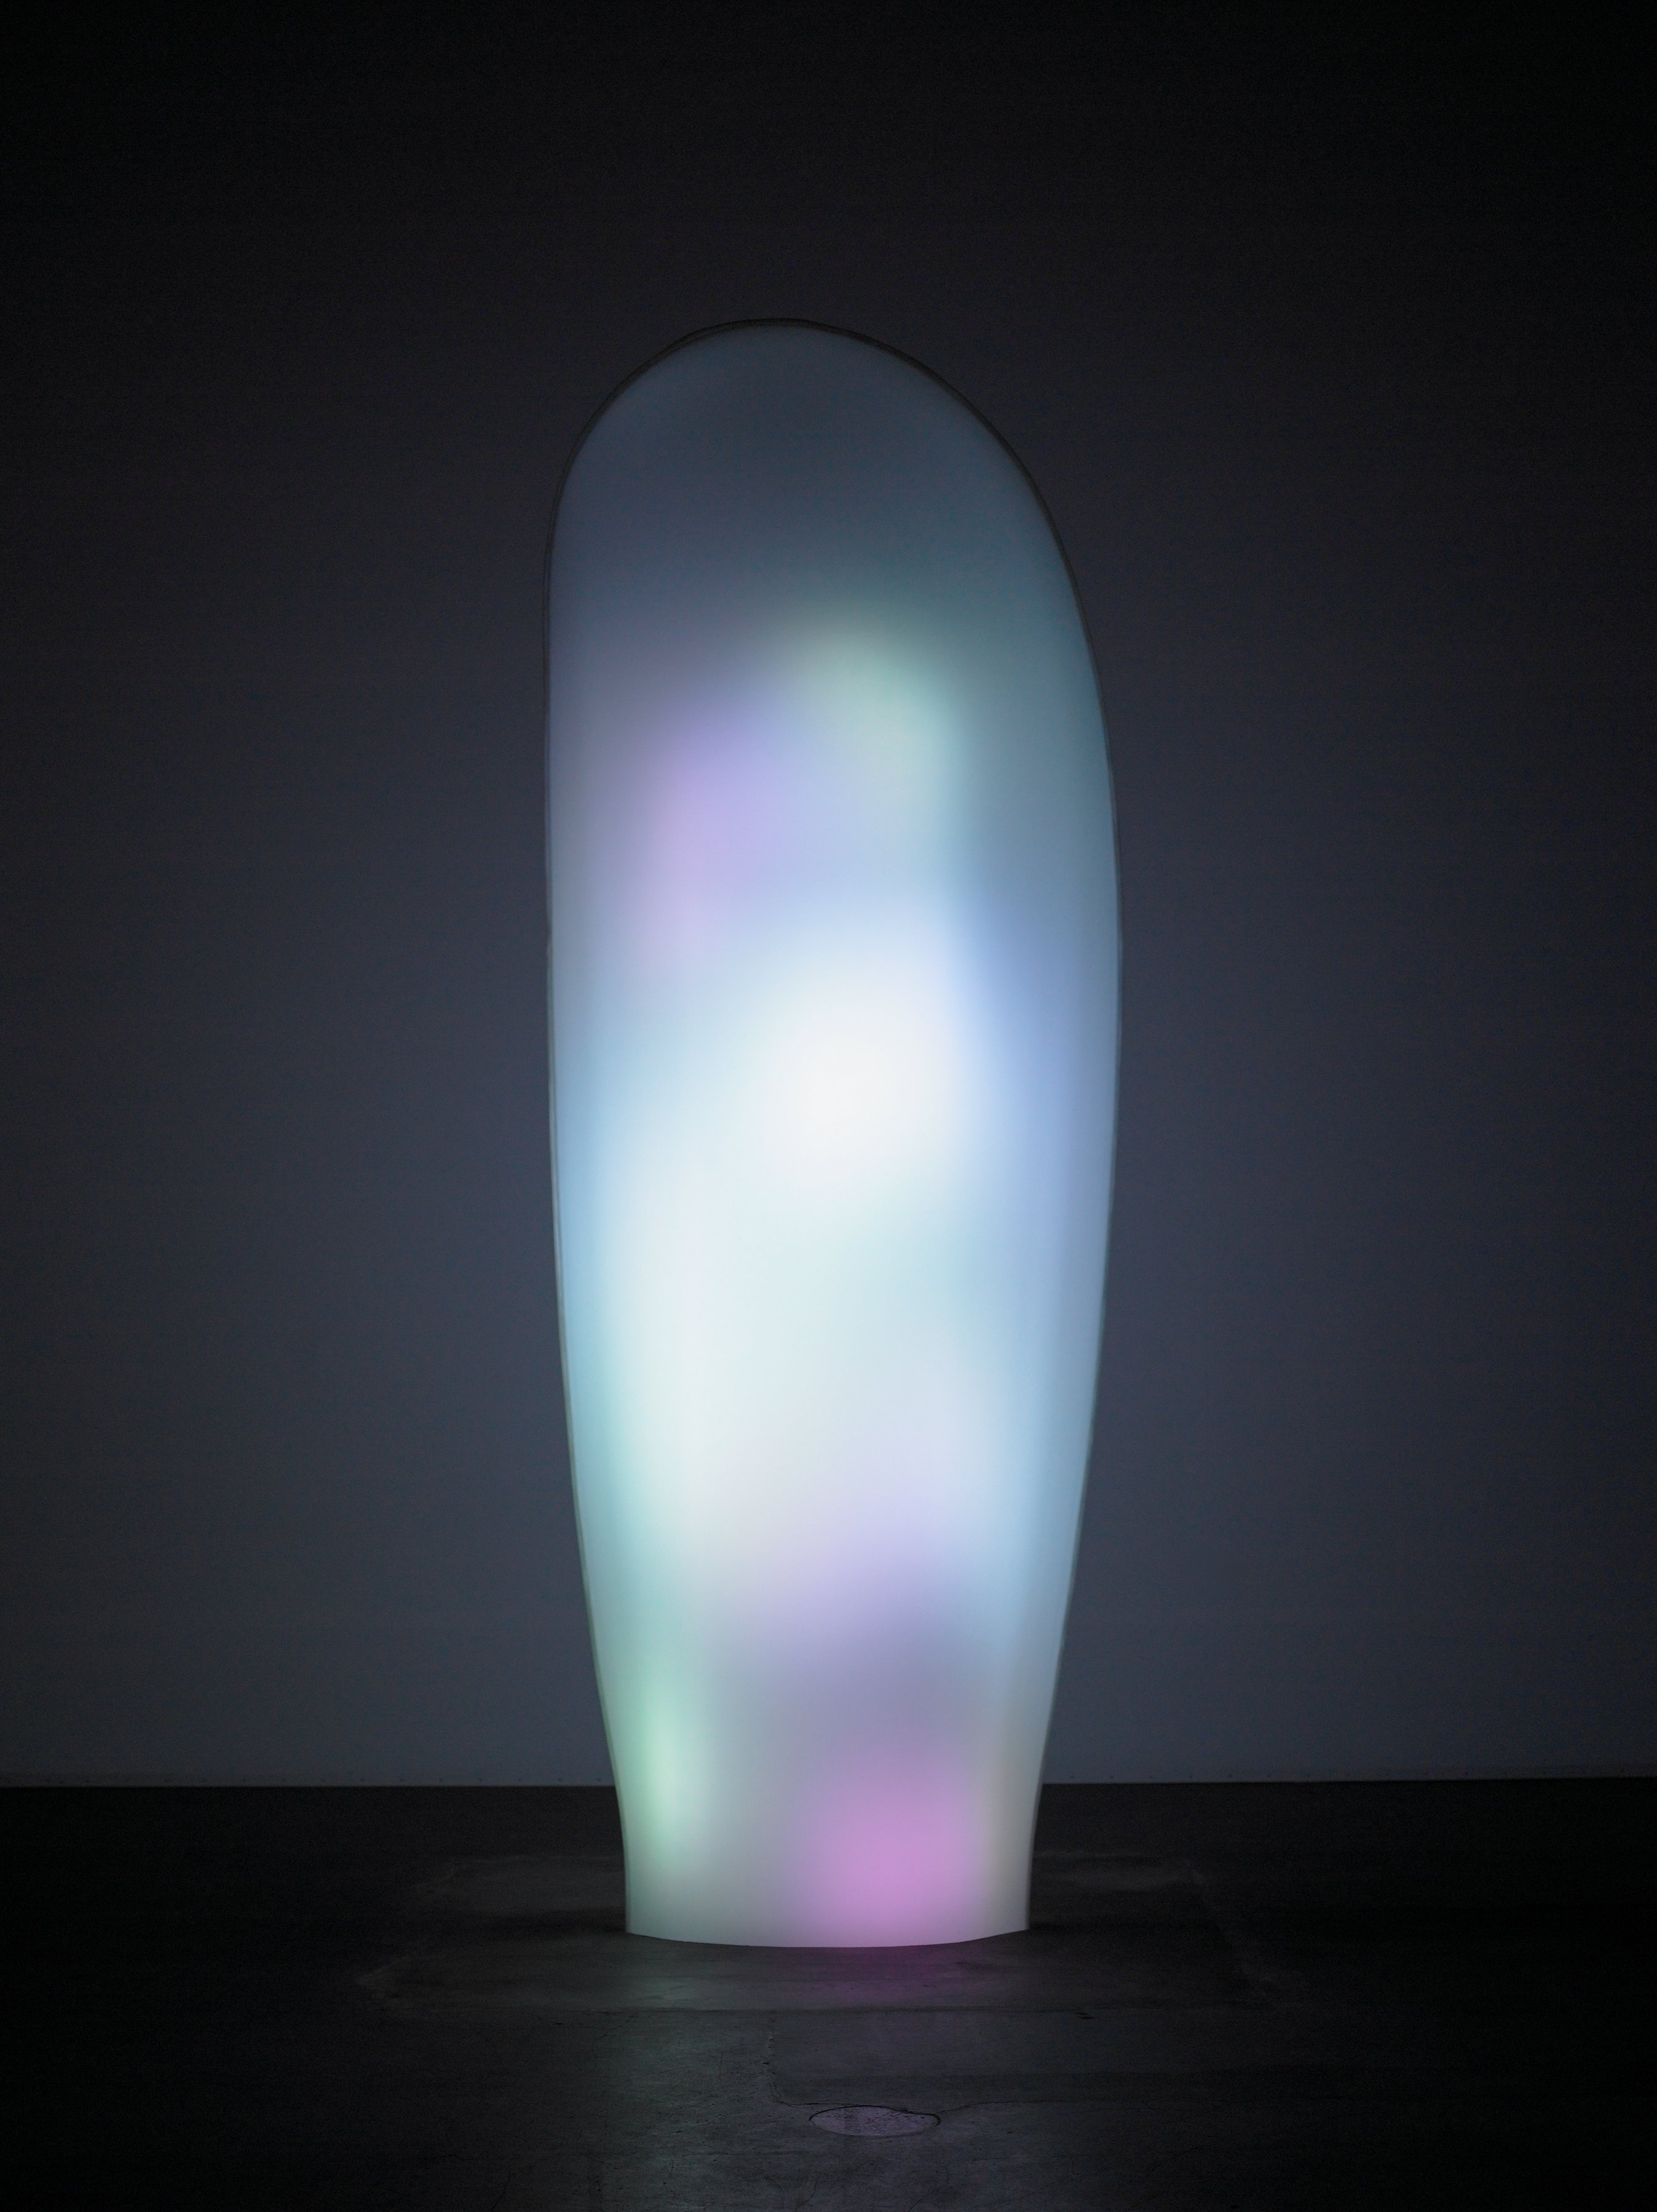

© Mariko Mori Studio, Photo: Richard Learoyd

For more information, please contact:
Zumtobel Lighting GmbH
Nikolaus Johannson
Head of Brand Communication
Schweizer Strasse 30
A-6851 Dornbirn

Tel. +43-5572-390-26427
Mobile +43-676-8920-3202
E-mail nikolaus.johannson@zumtobel.com

www.zumtobel.com

About Zumtobel
Zumtobel is a leading international supplier of integral lighting solutions that enable people to experience the interplay of light and architecture. As a leader in innovation, the luminaire manufacturer provides a comprehensive range of high-quality luminaires and lighting management systems for the most varied application areas of professional interior lighting – including offices and educational facilities, presentation and retail, hotels and wellness, health and care, art and culture as well as industry and engineering. Zumtobel is a brand of Zumtobel AG with its head office in Dornbirn, Vorarlberg (Austria).

Zumtobel. The Light.

