Press release
Dornbirn, March 2012

Double winner: two red dot awards: product design for Zumtobel

Two Zumtobel products won a “red dot award: product design 2012”. The Iyon LED spotlight system and the Tecton LED continuous-row lighting system could not fail to impress the jury thanks to their outstanding product design and efficient lighting technology. Luminaires by Zumtobel are based on the aspiration that they provide the best light for people and the environment, and on the conviction that successful design must be based on potential applications and user requirements. By being awarded these two red dot awards, Zumtobel products were once again able to prove their quality of innovation and design.

Iyon – LED spotlight range
The Iyon spotlight range incorporates state-of-the-art LED technology in a sophisticated design by Delugan Meissl Associated Architects. Its flowing lines give the Iyon spotlight an elegant look while ensuring perfect functionality. The unique lens-reflector system provides brilliant accent lighting with a variety of beam angles.

Tecton – continuous-row LED system
Zumtobel's Tecton continuous-row lighting system designed by Billings Jackson Design makes it easy for architects, designers and electricians to fulfil the most varied lighting tasks using one consistent system. Thanks to the introduction of Tecton LED, the pre-wired 11-pole continuous-row system now also allows for integration of high-quality LED components while maintaining complete system compatibility and absolute flexibility. This does not affect Tecton's well-known easy no-tool installation.

Zumtobel. The Light.
red dot design award
The red dot design award is one of the most renowned design prizes worldwide. The “red dot” awarded at this competition has become established as a coveted international quality mark. This year, 1,800 manufacturers and designers from 58 countries have submitted a total of 4,515 products to compete for the red dot. The awards will be handed over and celebrated at the red dot gala at the Aalto Theatre in Essen on 2 July 2012, with more than thousand international guests present, among them designers, business experts, politicians and media representatives.

Brief profile
Zumtobel is a leading international supplier of integral lighting solutions that enable people to experience the interplay of light and architecture. As a leader in innovation, the luminaire manufacturer provides a comprehensive range of high-quality luminaires and lighting management systems for the most varied application areas of professional interior lighting – including offices and educational facilities, presentation and retail, hotels and wellness, health and care, art and culture as well as industry and engineering. Zumtobel is a brand of the Zumtobel AG group with its head office in Dornbirn, Vorarlberg (Austria).

For more information, please contact:
Zumtobel Lighting GmbH
Nadja Frank
PR Manager
Schweizer Strasse 30
A-6851 Dornbirn

Tel. +43-5572-390-1303
Fax +43-5572-390-91303
nadja.frank@zumtobel.com
www.zumtobel.com

Captions:
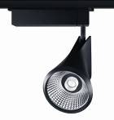

B1_ For the Iyon spotlight range, the Delugan Meissl Associated Architects studio has incorporated state-of-the-art LED technology in a sophisticated design.

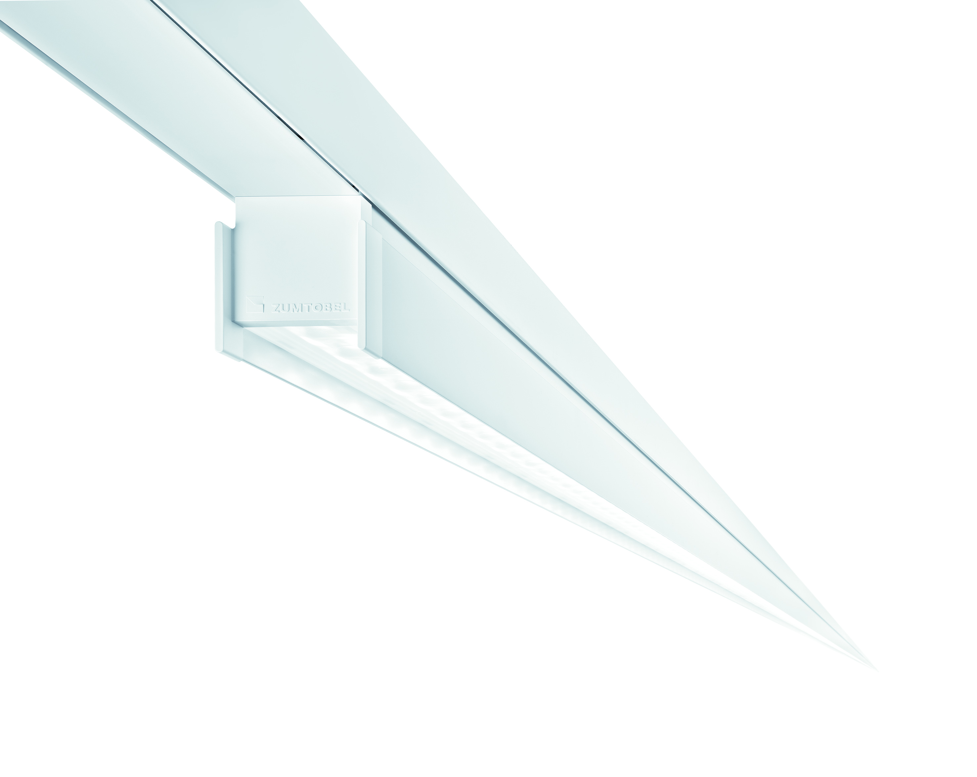

B2_ The Zumtobel Tecton LED continuous-row lighting system designed by Billings Jackson Design cannot fail to impress with its unobtrusive design and a variety of application options.

