Press release
Dornbirn/London, August 2012

Opening of Zumtobel Lighting UK Light Centre

Zumtobel Lighting’s move to upmarket Chalfont St. Peter in the county of Buckinghamshire, involved the construction of one of Zumtobel's most modern and inspirational Light Centres, covering an area of 340 m². Easily accessible from London, the new Light Centre is not only a showcase for a comprehensive range of lighting solutions, it is also a place to meet lighting professionals and those with a passion for light and architecture.

Zumtobel presents trend-setting lighting solutions for various application areas in 18 Light Forums and Light Centres around the world. In Chalfont St. Peter, visitors can learn about innovative lighting application techniques and the innovative luminaires that aid intelligent lighting designs, through application spaces, known as ‘App Spaces’. Besides personalised advice, emphasis is always placed on experiencing light as a medium.

First daylight showroom
The Zumtobel brand is inextricably associated with aesthetically attractive design and a clear stylistic idiom. This purist design flare is evident at the Chalfont St. Peter Light Centre where Zumtobel’s full lighting design concepts and capabilities are featured. Highly atmospheric centre-stage settings and selective accent lighting, allow visitors to experience the ways in which light can be used to create the right atmosphere and ideal lighting conditions in different situations. The emphasis is on presenting lighting solutions using the latest cutting-edge LED technology which combine energy saving with lighting comfort.

The design concept of the Light Centre demonstrates Zumtobel's lighting expertise and knowledge of the uses of light. It also includes a vast array of distinctive features including, the first daylight demonstration in which visitors can have first-hand experience of the interaction between daylight and artificial lighting.

Focusing on customers' needs
Austrian lighting manufacturer Zumtobel has operated its sales organisation in the UK for 26 years. Having been fortunate enough to provide lighting solutions to some of the most exquisite and iconic buildings all over the UK, Zumtobel aspires to drive innovation, market education and best practice lighting.
"The Light Centre is based on an application cube concept which allows us to provide hands-on presentations and demonstrations of our lighting design ideas to visitors for every application, including, offices, retail, education, health & care, art & culture and façades & architecture. Authentic staging makes it possible to experience light and its effects in a completely unique way. This enables us to cater to the specific requirements of our customers and demonstrate alternative solutions", comments Steve Shackleton, Zumtobel Lighting’s Marketing Director, describing this new facility and its capabilities. “Our new Light Centre will help drive our concepts, innovations and education even further still. The Light Centre is a direct response to growing business and the need for extra space to demonstrate our lighting capabilities and our ability to deliver personalised customer advice.” he explains.

Zumtobel. The Light.

Captions:

Caption 1:
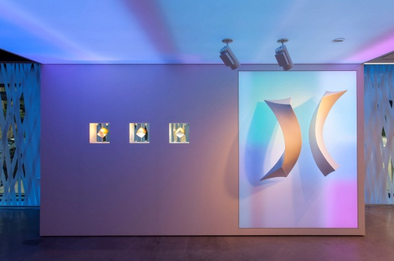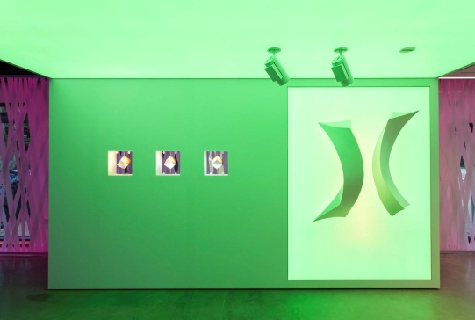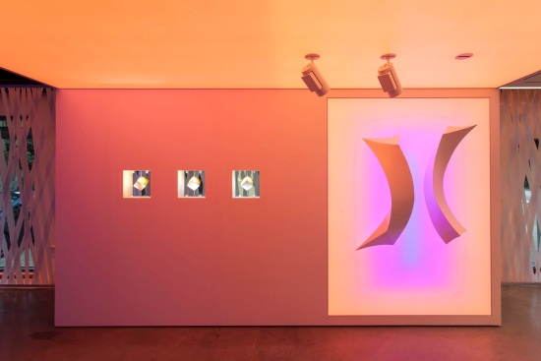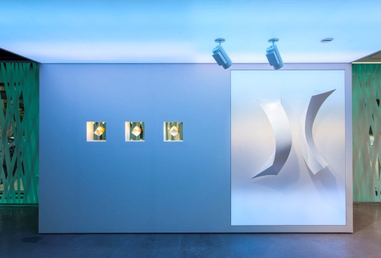
Besides personalised advice, emphasis is always placed on experiencing light as a medium.

Caption 2:
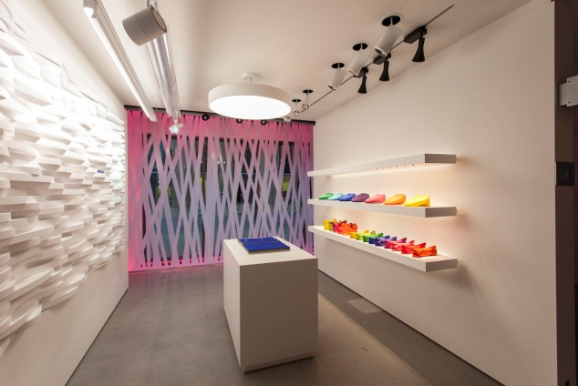
The Chalfont St. Peter Light Centre has a vast array of distinctive features such as the first daylight demonstration in which it is possible to experience the interaction of daylight and artificial lighting.

Caption 3:
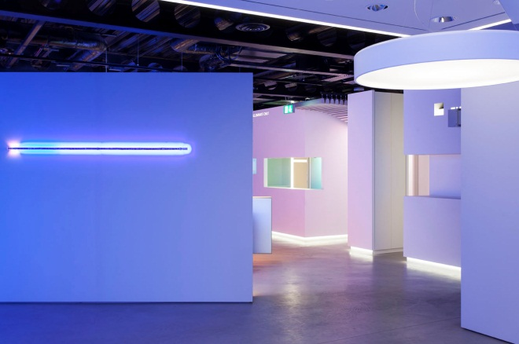
Highly atmospheric centre-stage settings and selective accent lighting allow visitors to experience the ways in which light can be used to create the right atmosphere and ideal lighting conditions in various situations.

Brief profile
Zumtobel is a leading international supplier of integral lighting solutions that enable people to experience the interplay of light and architecture. As a leader in innovation, the luminaire manufacturer provides a comprehensive range of high-quality luminaires and lighting management systems for the most varied application areas of professional interior lighting – including offices and educational facilities, presentation and retail, hotels and wellness, health and care, art and culture as well as industry and engineering. Zumtobel is a brand of the Zumtobel group with its head office in Dornbirn, Vorarlberg (Austria).

For more information, please contact:

Zumtobel Lighting GmbH  NikolausJohannson  Head of Brand Communication  Schweizer Strasse 30  A-6851 Dornbirn  Tel. +43-5572-390-26427  Fax +43-5572-390-926427  nikolaus.johannson@zumtobel.com  www.zumtobel.com | Zumtobel Lighting GmbH  Britta Maier  PR Manager  Schweizer Strasse 30  A-6851 Dornbirn  Tel. +43-5572-390-1303  Fax +43-5572-390-926587  britta.maier@zumtobel.com  www.zumtobel.com

