Press release
Dornbirn, July 2012

Zumtobel “Map of Light” app now linked to product catalogue

With effect from this week, the Zumtobel “Map of Light” app includes more than 1000 accessible projects, and a new version upgraded for iPhone and iPad is available in the App Store. The free app has been optimised for iPad 3, offering new services to users thanks to new functions. What is new is that Zumtobel's product catalogue including technical data for the entire product range is now available on the “Map of Light”.

On the “Map of Light” created by luminaire manufacturer Zumtobel, users can now easily and quickly access more than 1000 lighting solutions across the globe. All the information and pictures pertaining to any project can be seen at a glance, allowing users to search according to application area or project location. In this way, the “Map of Light” provides fascinating insights into the variety of lighting solutions and concepts available. At the same time, it is a very useful tool for lighting designers and architects: they can access current reference projects at any time, plus the products used for these and a picture gallery. In addition to the new link to the Zumtobel product catalogue, information on current Zumtobel product innovations can be found under Highlights. The application is available free of charge in the App Store at: http://itunes.apple.com/gb/app/map-of-light/id397335153?mt=8

More than 1000 projects provide users with insights into the world of light
Project no. 1000 on the “Map of Light” is a special highlight: at the McLaren showroom in Vienna, Zumtobel demonstrates how light is used to set a special brand centre stage while meeting the highest requirements in terms of a sustainable lighting solution. The lighting concept provides the requisite degree of flexibility to adjust the lighting situation to the various exhibition situations and car models presented. In addition, trend-setting LED luminaires have been installed in order to increase energy efficiency while ensuring optimum lighting quality.

Zumtobel. The Light.

Brief profile
Zumtobel is a leading international supplier of integral lighting solutions that enable people to experience the interplay of light and architecture. As a leader in innovation, the luminaire manufacturer provides a comprehensive range of high-quality luminaires and lighting management systems for the most varied application areas of professional interior lighting – including offices and educational facilities, presentation and retail, hotels and wellness, health and care, art and culture as well as industry and engineering. Zumtobel is a brand of the Zumtobel group with its head office in Dornbirn, Vorarlberg (Austria).

Zumtobel Lighting GmbH Zumtobel Lighting GmbH
NikolausJohannson Nadja Frank
Head of Brand Communication PR Manager
SchweizerStrasse 30 SchweizerStrasse 30
A-6850 Dornbirn A-6850 Dornbirn

Tel. +43-5572-390-26427 Tel. +43-5572-390-1303
Fax. +43-5572-390-926427 Fax. +43-5572-390-91303
nikolaus.johannson@zumtobel.com nadja.frank@zumtobel.com
www.zumtobel.com www.zumtobel.com
Captions:

(Photo credits: Zumtobel)

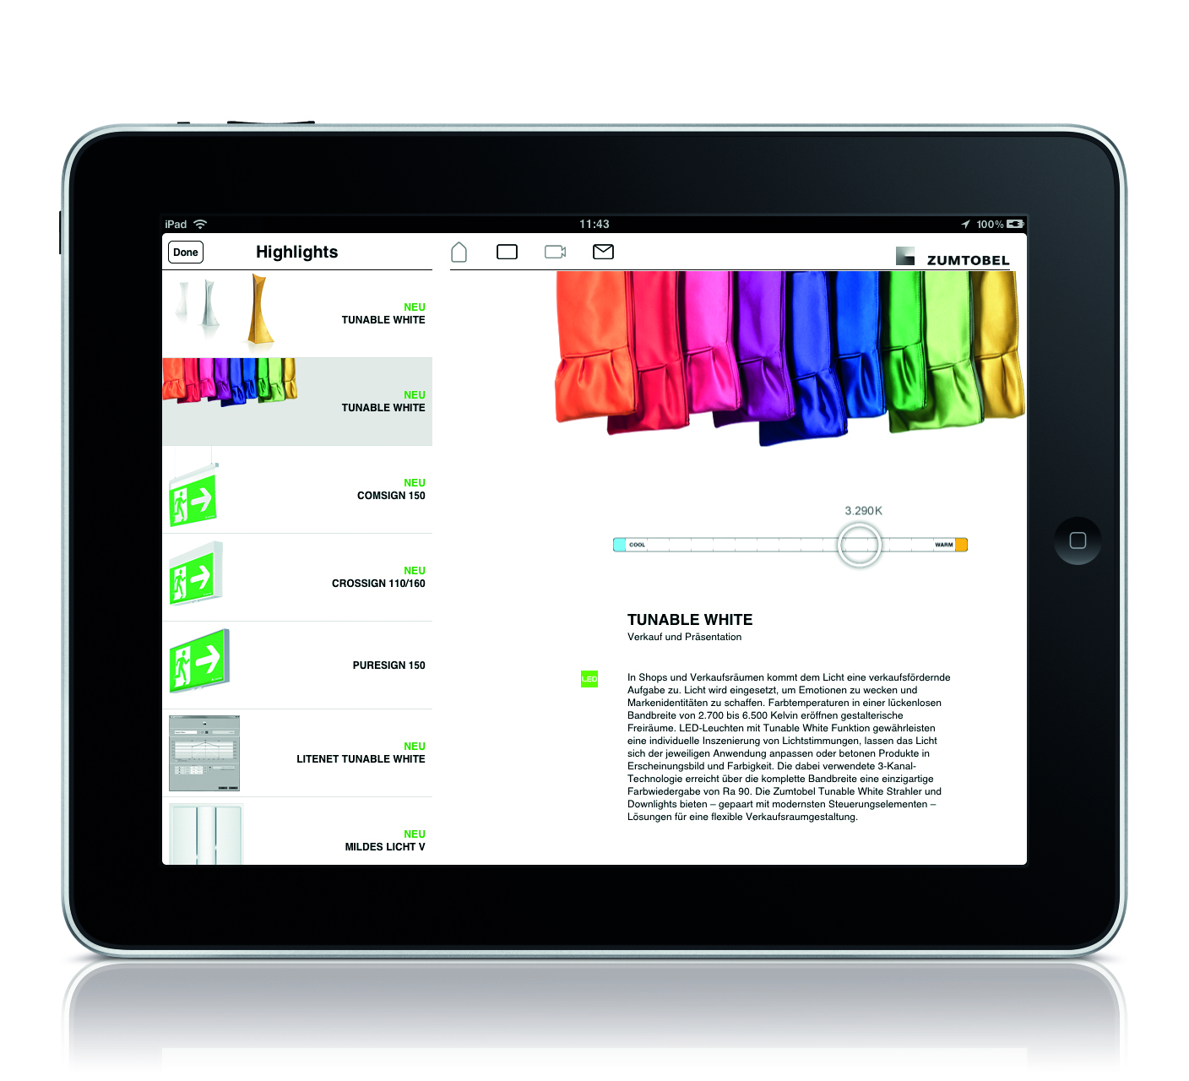

Caption 1: With immediate effect, a new, upgraded version of the Zumtobel “Map of Light” is available in the App Store.

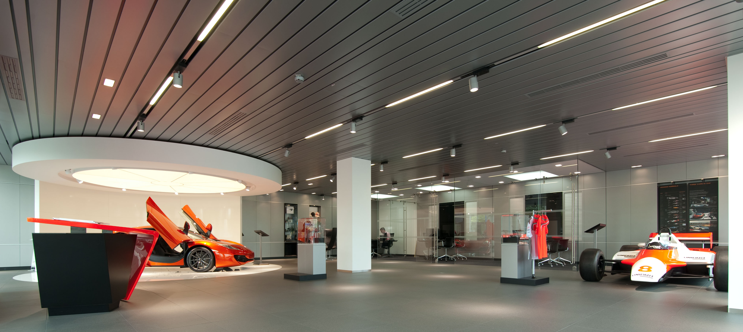

Caption 2: Project no. 1000 on the Zumtobel “Map of Light”: the MacLaren showroom in Vienna.

