Press release
Dornbirn, November 2011

“Harpa” – Reykjavik's new concert hall
Emotional and full of energy, like Iceland itself

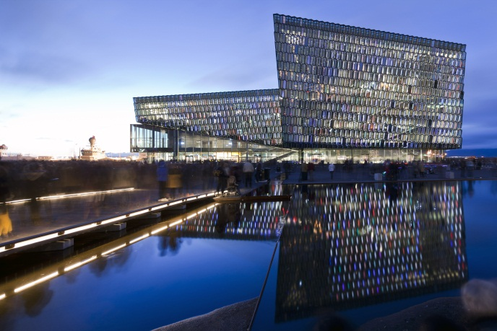
More than almost any other country, Iceland is characterised by the elemental forces of Nature. The island, which is situated slightly below the polar circle, has its fair share of barren volcano landscapes, boiling lakes and steam-spraying geysers as well as huge glaciers, biting winds and mysterious Northern Lights. Until recently, the cosmopolitan capital of Reykjavik, the home of some 120,000 people, was hardly able to host any large-scale cultural events. In August 2011, the new “Harpa” Concert Hall and Conference Centre was opened, which has now room for congresses, conferences and concerts and is also the residence of the Icelandic Opera and the Iceland Symphony Orchestra. The building created incorporates a 1800-seat concert hall and three smaller halls and will surely become a cultural highlight also on an international level. However, thanks to pictorial transformation of typical Icelandic natural phenomena into built architecture, Harpa is also deeply rooted in the country's tradition.

The seamless interplay of local and global influences is also reflected by the designers involved: basically, Henning Larsen Architects and Batteríið Architects from Denmark and Iceland, respectively, and acoustics designers from the New-York-based firm Artec Consultants. Of particular importance for the project was, however, Danish-Icelandic artist Ólafur Elíasson, who created the design for the building's unique glass shell and its illumination, which was implemented in collaboration with Zumtobel, his long-standing expert partner when it comes to lighting solutions. His lighting concept was based on the desire to set the stage for light as a transcendent event where the source of light remains invisible.

Art and architecture – an indivisible unit
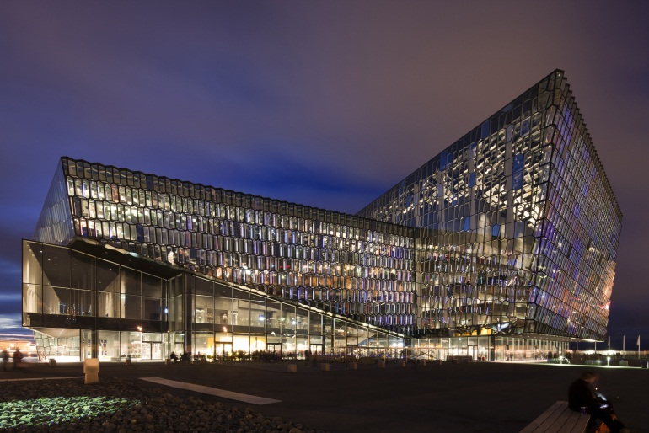
Situated near the Atlantic waterfront against the backdrop of a vibrant harbour and a rugged coastline, the spacious 28,000 m² concert hall and conference centre radiates the sublimeness of a multi-faceted crystal. The façade elements are inclined at various angles, resulting in reflection effects that make some surfaces appear opaque, while others allow deep insights into the building's interior. Uniformly distributed across the honeycomb-like façade structure, individual glass panels sparkle mysteriously in green, yellow, orange or their complementary colours. For this purpose, dichroic glass was used that reflects or lets pass certain wavelenghts of the light, depending on the viewer's perspective, the weather, time of day and season. Thanks to these reflections and permanent changes in colour tone and colour intensity, the building seems to capture light in a magical way.

A particular three-dimensional effect is achieved on the south façade facing the city centre, consisting of a structure that is inclined slightly outwards and comprises a total of some 1000 prism-shaped glass pieces stacked on top of each other. Eliasson's design of the shape and arrangement of these twelve-sided “quasi bricks” made of sharp-edged hollow steel sections was inspired by the columnar basalt cliffs originating from volcano eruptions that are a common sight in Iceland. “The modules seem to be translucent and light, yet the entire façade is made up from them”, he explains his concept. The façade is not to be misunderstood as a work of art merely applied to the building, but as part of the architecture that also fulfils functional tasks. For example, it bears ceiling loads, acts as a thermal buffer and reduces noise immission into the building. “The result is a bright and spacious façade in lively contrast to Harpa's rather monolithic interior,” adds Elíasson.

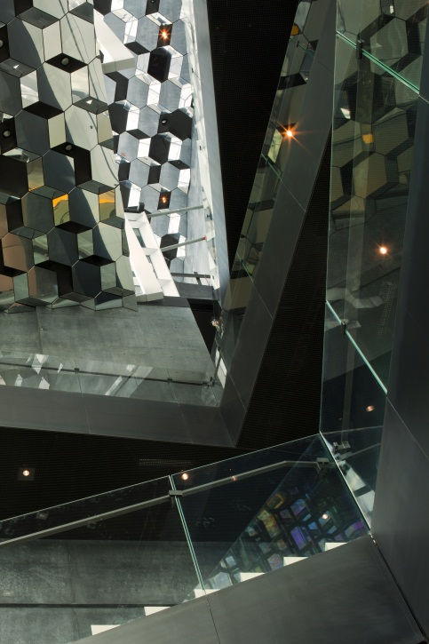
Kaleidoscopic interplay of light and shadow
Viewed from the foyer, the modules form a dematerialised building shell which, thanks to its reflections, colour and light effects, calls to mind the Northern Lights phenomenon. This is especially obvious in winter, with the sun low on the horizon, when the foyer is immersed in a kaleidoscopic interplay of light and shadow that almost reaches the ceiling. This scenario is further enhanced by the highly specular elements mounted on the ceiling. The indivisible unit formed by art and architecture can be experienced in particular after night has fallen, when the south façade begins to glow. During the day, even attentive observers fail to discover the linear LED luminaires mounted inside the structure. For this purpose, Elíasson developed, in collaboration with lighting solution expert Zumtobel, a completely new type of luminaire which, thanks to its design and colour, can be integrated nearly invisibly into the prismatic structure. The first prototypes of these illuminated modules were developed soon after the start of the project; they were presented in 2006 at the Architectural Biennial in Venice for the first time and then further refined until the building was completed.

Lighting art and artificial lighting
What is so special about these luminaires with a length of barely 1.37 m and a total output of 13.2 W each, is not only their shape that results from the continuation of the linear geometry of the modules and the smallest possible mounting height. In order to achieve the impression that the modules are not only illuminated but themselves shining, and in order to obtain completely uniform colours, mainly two aspects had to be considered: firstly, the three-coloured RGB LEDs must not be visible from outside. Moreover, their radiation angle must be no more than 90°, instead of the usual 180°. This was achieved by using a special housing where the light emitted by the LEDs has to pass through a “light mixing chamber” before it penetrates a light scattering plastic section consisting of several components. Secondly, neither fixing points nor cables must be visible. Therefore, the LEDs are connected to the mains supply and data network via invisibly laid cables, partly within the bearing structure, partly in the sealing joints of the glass modules. In terms of colour and lighting intensity, the LED lines should be individually controlled and dimmable down to 1% of the maximum light output, enabling lighting scenarios ranging from spherical colour sequences to the presentation of animated pictures.

Fire, water, earth and air
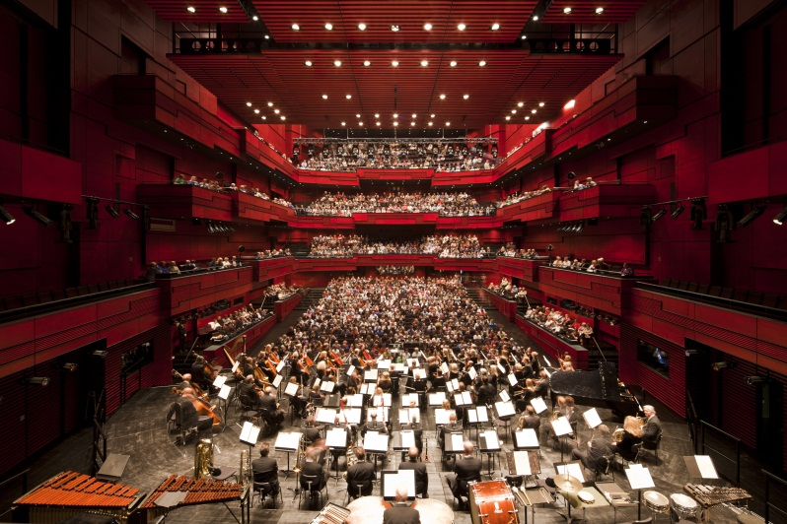
During the months following inauguration, the softly pulsating light emitted by these LEDs tinged the building's forecourt and foyer with a mysterious blue light slowly extending over the reflections in the glass panels of the modules and the highly specular ceiling down to the basalt-grey exposed concrete walls of the concert halls. This virtual coating of ice is in sharp contrast to the main concert hall called “Eldborg” (Fire Castle). Named after one of Iceland's most beautiful volcanoes, the three-gallery hall seems to virtually glow in warm shades of red, creating a both cosy and stimulating atmosphere.

In order to provide the best possible acoustic quality for music and spoken-word events, two “echo chambers” covering the entire height of the hall were built behind the side walls. These rooms can be connected to the concert hall via several heavy concrete doors, thus increasing its spatial volume – and its reverberation time – significantly. For this finely adjustable acoustic system to be used to full extent, measurements had to be made to certify that all luminaires installed there by Zumtobel are 100% noiseless. Therefore it was necessary to install the dimmers required for the dimmable Panos downlights which, due to their warm colour temperature, provide pleasant ambient lighting e.g. during the intervals, outside the hall. For indirect – and also dimmable – lighting of the side walls, the Tecton continuous-row lighting system was installed, which is absolutely flicker-free and noiseless thanks to appropriate ballasts as standard, i.e. without any costly conversion or retrofitting efforts. Precisely calculated overlapping of lamps ensures no-shadow lighting effects.

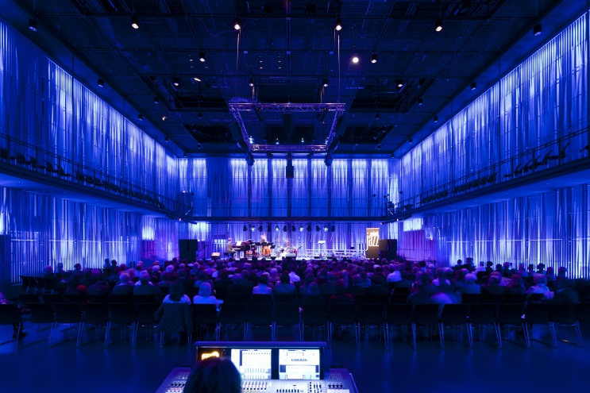
Each of the smaller halls is dedicated to one of the three other elements. “Kaldalon” – named after a bay in North Western Iceland – represents the element of water. “Silfurberg”, named after a translucent calcite crystal, represents earth, while “Norðuljós” symbolises air. For the Norðuljós lighting concept, the designers opted for backlit walls lined with wooden vanes to reflect the Northern Lights that are also visible in Reykjavík. To achieve this, Zumtobel conducted numerous experiments and created 1:1 models, in collaboration with the architects, to finally develop an LED solution providing coloured lighting scenes with spherical effects. Analogue to the south façade modules, the light in this hall, too, should be perceived as a transcendent event with invisible light sources.

It was a long way from the architects' and artists' concept to today's Harpa Concert Hall and Conference Centre, which required close collaboration of all those involved, many experiments and detailed work with high precision. This complex adjustment and implementation process, which was delayed for a few years because of Iceland's economic crisis, has now been rewarded with an impressive building that is as emotional and full of energy as Iceland itself.

Zumtobel. The Light.

Brief profile
The Zumtobel brand is a leading international supplier of integral lighting solutions that enable people to experience the interplay of light and architecture. As a leader in innovation, the luminaire manufacturer provides a comprehensive range of high-quality luminaires and lighting management systems for the most varied application areas of professional interior lighting – including offices and educational facilities, retail and presentation, hotels and wellness, health and care, art and culture as well as industry and engineering. Zumtobel is a brand of the Zumtobel AG group with its head office in Dornbirn, Vorarlberg (Austria).

Captions:

B1_ Impressive to look at: situated directly at the Reykjavík harbourfront, the new Harpa Concert Hall and Conference Centre covers 28,000 m².

B2_ At dusk and at night, the building is surrounded by a fascinating aura, when the building's south façade seems to shine from within. A special LED lighting solution was developed by lighting artist Ólafur Elíasson in collaboration with lighting solution expert Zumtobel.

B3_ An exciting interplay of light and shadow is visible in the foyer, further enhanced by the highly specular elements mounted on the ceiling.

B4_ The “Fire Castle” concert hall seems to virtually glow in shades of red. Downlights and continuous-row systems by Zumtobel create a mystical and at the same time stimulating atmosphere.

B5_ The smaller halls, too, reflect the concept developed by Elíasson and Zumtobel: light is perceived as a transcendental event with invisible sources of light.

For more information, please contact:

Zumtobel Lighting GmbH
Nadja Frank
PR Manager
Schweizer Strasse 30
A-6851 Dornbirn

Tel. +43-5572-390-1303
Fax +43-5572-390-91303
nadja.frank@zumtobel.com
www.zumtobel.com
Publication of this document is free if due acknowledgement is made: Zumtobel

